**HEATER SPACE COAL / OIL BURNING**

These Heaters are used to warm inside of the Tents at high altitudes, to give maximum comfort to personnel, without any risk of suffocation from smoke or fuel gases, since the Heaters are designed and manufactured to ensure that no such fuel gases or smoke leaks into the tents but safely passes out of the tents via the chimney provided with the Heater.  
  
It is manufactured in two models :  
1. Coal Burning - using coal as fuel.  
2. Oil Burning - using kerosene oil as fuel.

**APPLICATION OF OIL BURNING:**

* Used to warm inside of the tents at high altitudes
* No risk of suffocation
* No leakage of fuel gases or smokes.
* Smokes passes out through Chimney.
* Fuel used : Coal

**PARTS OF THE BURNER**

* **Aluminium Sheet**
* **Elbow**
* **Door**
* **Chimney**
* **Chimney pipe**
* **Burner**
* **Bottom part**
* **Supporting leg**
* **Aluminium sheets** are the main components of the burner.
* **Elbow** are used to fit the chimney pipe in the burner.
* **Door of the burner** are used to put the burner inside it by open the door & then close it.
* **Chimney** are mainly called to a single pipe but **chimney pipe** means to the simultaneously five pipes fitted together to form a chain of pipes helps to take out all all smoke of the burner to the atmosphere .
* **Burner** plays very important role , it is used to red hot the whole the substance.
* **Bottom part** is used to support the burner placed inside.
* **Supporting leg** are used to support the burner . it consists of atleast 3 legs.
* There are some pictures of the parts which are as follows –

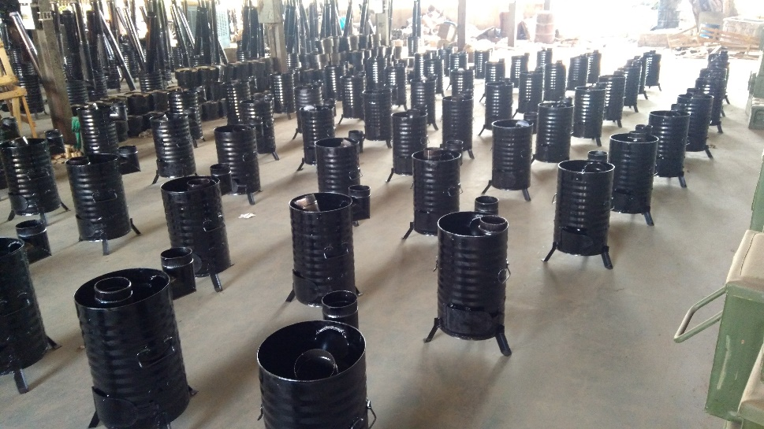

Fig.9. a group of HSOB

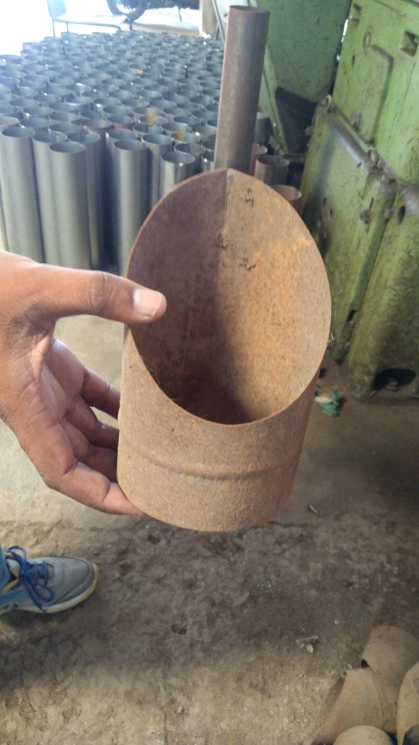 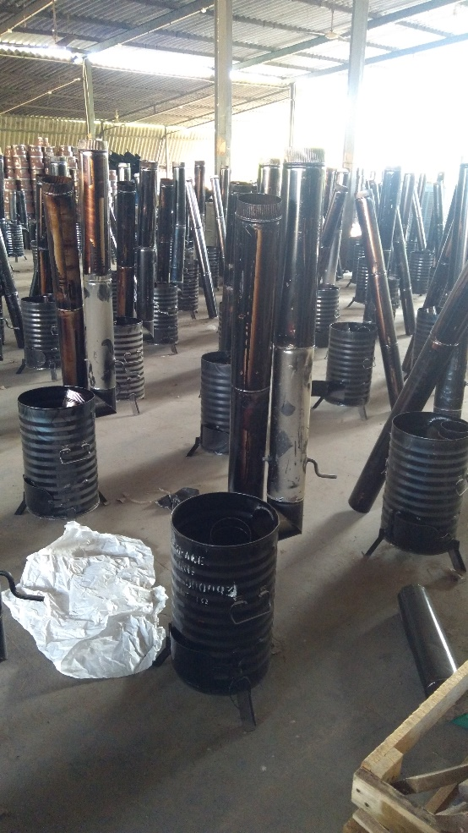

Fig.10. A Elbow Fig.11. HSOB with Chimney pipe

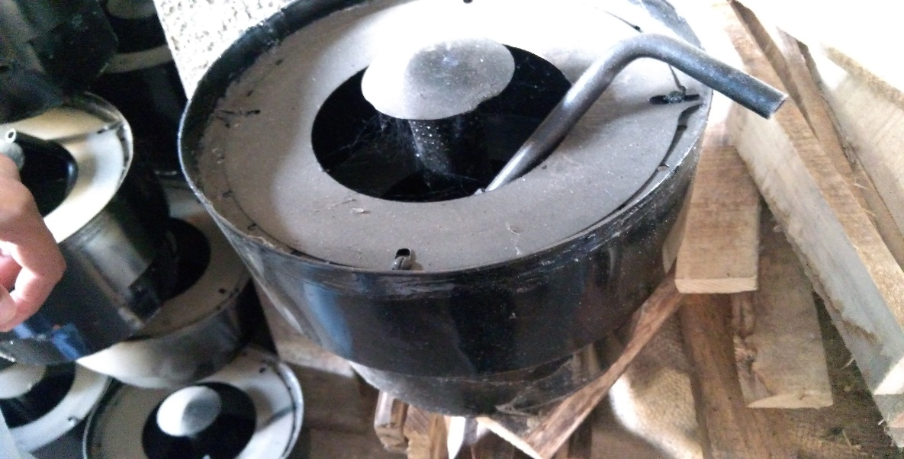

Fig. 12. A Burner

**WORKING OPERATION**

1. SIZING PROCESS

2. PUNCHING PROCESS

3. PRESSING PROCESS

4. ROLLING PROCESS

5. WELDING PROCESS – 1. GAS WELDING

2. SEAM WELDING

6. SURFACE FINISH PROCESS

7. PAINTING PROCESS

**DETAIL OF OPERATIONS**

* **SIZING PROCESS:**
* **Sizing** or **size** is any one of numerous substances that is applied to, or incorporated into, other materials — especially papers and textiles — to act as a protective filler or glaze. **Sizing** is used in papermaking and textile **manufacturing**to change the absorption and wear characteristics of those materials.
* In **ORDNANCE EQUIPMENT FACTORY KANPUR** , oil burner is sizing through the machine , named as **SHEARING MACHINE.**
* **Shearing machine** is a sheet metal forming machine that used to cut sheet metal. Like as 4mm x 3200 sheet metal, you would need 4 x3200 hydraulic shearing machine to work out.
* In this factory , the size of oil burner is **464*876 mm** .
* 22 gauge is also another term to say the sizing of oil burner.

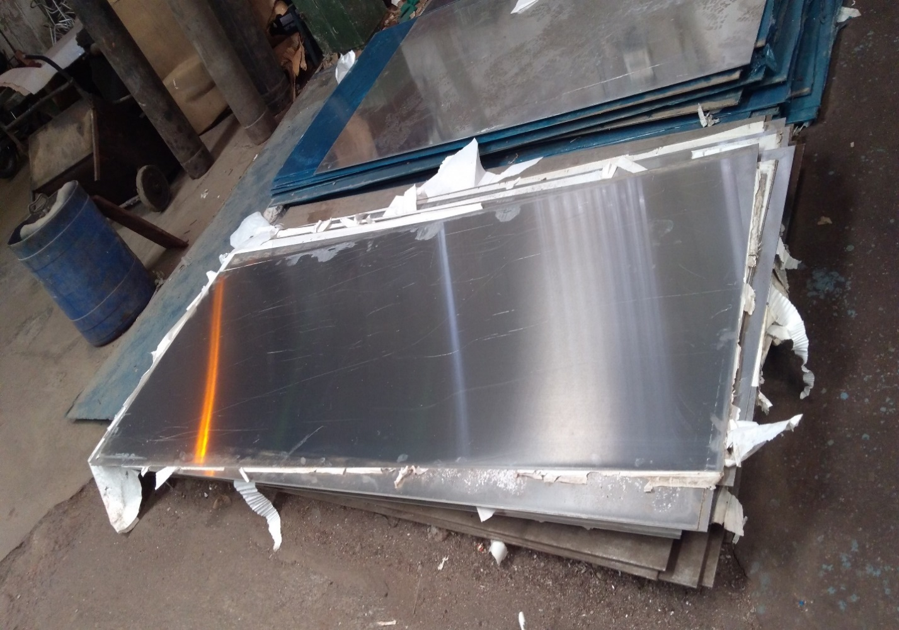

**Fig.1. 464*876 mm aluminium sheet**

* **PUNCHING PROCESS:**
* **Punching** is a metal forming process that uses a punch press to force a tool, called a punch, through the workpiece to create a hole via shearing.
* The punch often passes through the work into a die.
* Punching is often the cheapest method for creating holes in sheet metal in medium to high production volumes.
* The machine used for punching process is said to be **PRESSING MACHINE**.
* A **HYRADULIC PRESSING MACHINE** is a device using a hydraulic cylinder to generate a compressive force.
* It uses the hydraulic equivalent of a mechanical lever.
* In **ORDNANCE EQUIPMENT FACTORY KANPUR** , punching is formed in the two form , namely

CIRCLE (**ELBOWOF BURNER**) , RECTANGLE (**DOOR OF BURNER**).

* Not only elbow & door , even there are **eight small circular holes** are also formed for the support of the **ROD**.

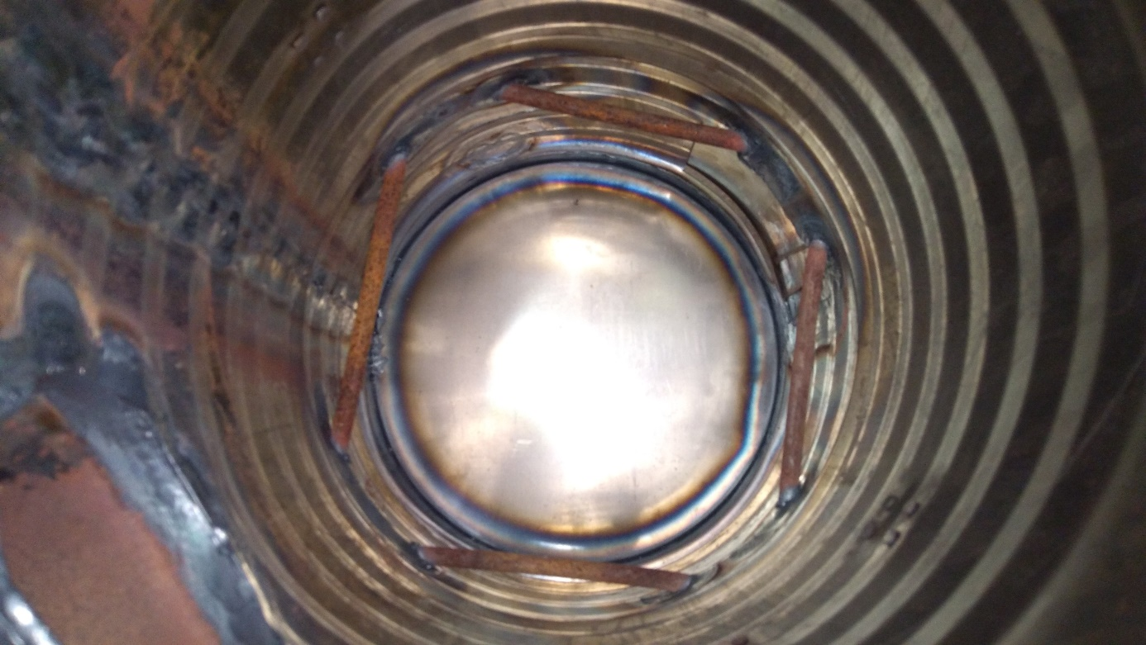

**Fig.2. 8 holes for the supporting 4 rod.**

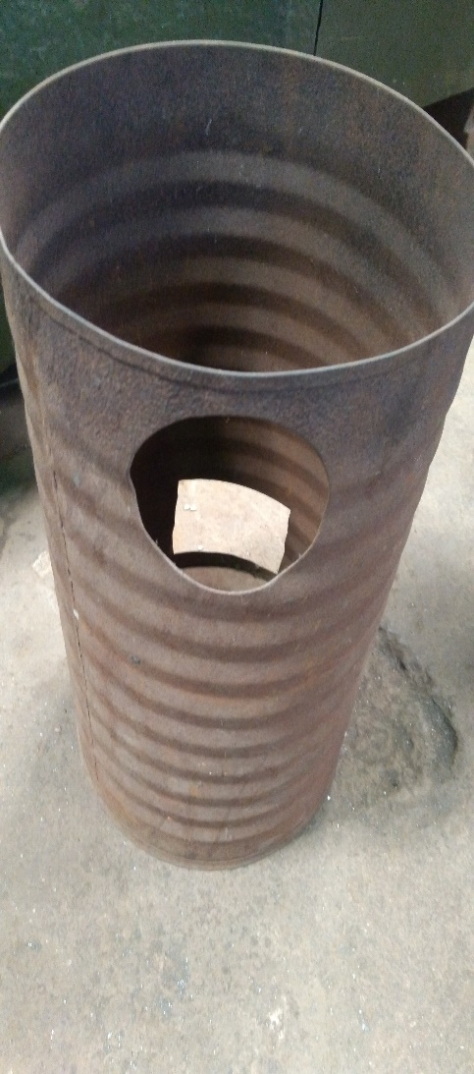 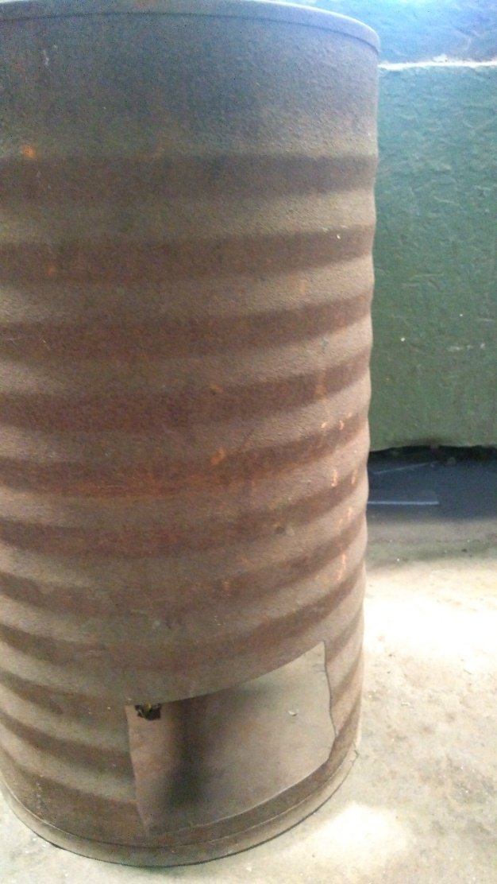

**Fig.3. Cutting Elbow in a burner. Fig.4. Cutting Door of the burner.**

* **ROLLING PROCESS:**
* In metalworking, **rolling** is a metal forming **process** in which metal stock is passed through one or more pairs of rolls to reduce the thickness and to make the thickness uniform.
* There are many types of **rolling processes**, including ring **rolling**, **roll** bending, **roll** forming, profile **rolling**, and controlled **rolling**.
* There are many types of rolling process named as -
  + - **Ring rolling**
    - **Roll rolling**
    - **Profile rolling**
    - **Controlled rolling**
* In **ORDNANCE EQUIPMENT FACTORY KANPUR ,** after punching process the sheet will formed the structure like a cylinder .
* The elbow & 8 holes & door of the burner are opposite sides of each other.
* The sheet are rolled under the rolling machine

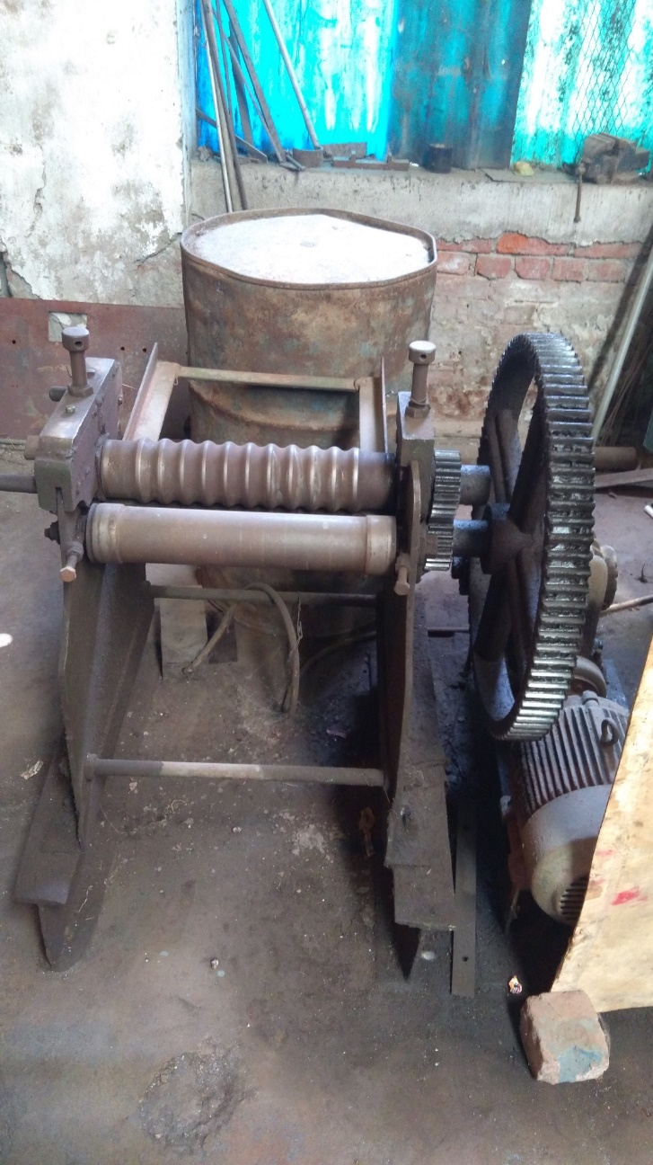

**Fig.5. Rolling machine**

* **WELDING PROCESS:**
* **Welding** is a fabrication or sculptural **process** that joins materials, usually metals or thermoplastics, by causing fusion, which is distinct from lower temperature metal-joining techniques such as brazing and soldering, which do not melt the base metal.
* In other words , **Welding** is a process of joining two metal pieces by the application of heat.
* **In ORDNANCE EQUIPMENT FACTORY KANPUR ,** there are two welding used to finish the infrastructure of a burner.They are **gas & seam welding.**
* There are many types of welding , some are as follows –

**Shielded Metal Arc Welding (SMAW)**

**Gas Metal Arc Welding (GMAW/MIG)**

**Flux Cored Arc Welding (FCAW)**

**Gas Tungsten Arc Gas Welding (GTAW/TIG)**

**Gas or Oxy Acetylene Welding And Cutting**

**Chemical welding**

**GAS WELDING:**

Oxy fuel welding (commonly called oxyacetylene welding) , oxy welding or gas welding in the U.S.) & oxy fuel cutting are process that use fuel gases & oxygen to weld & cut metals , respectively.

**In ORDNANCE EQUIPMENT FACTORY KANPUR , it is used to add the doors of the burner , add rods , add elbowS of the burner .**

**SEAM WELDING:**

SEAM WELDING is a variation of resistance spot welding . In the resistance seam welding , however the welding electrodes are motor driven wheels as opposed to stationary rods.

The result is a rolling resistance weld or non hermetic seam weld**.**

**In ORDNANCE EQUIPMENT FACTORY KANPUR,** it is used to make the chimneys for the burner so that all smoke goes out of the army tent.

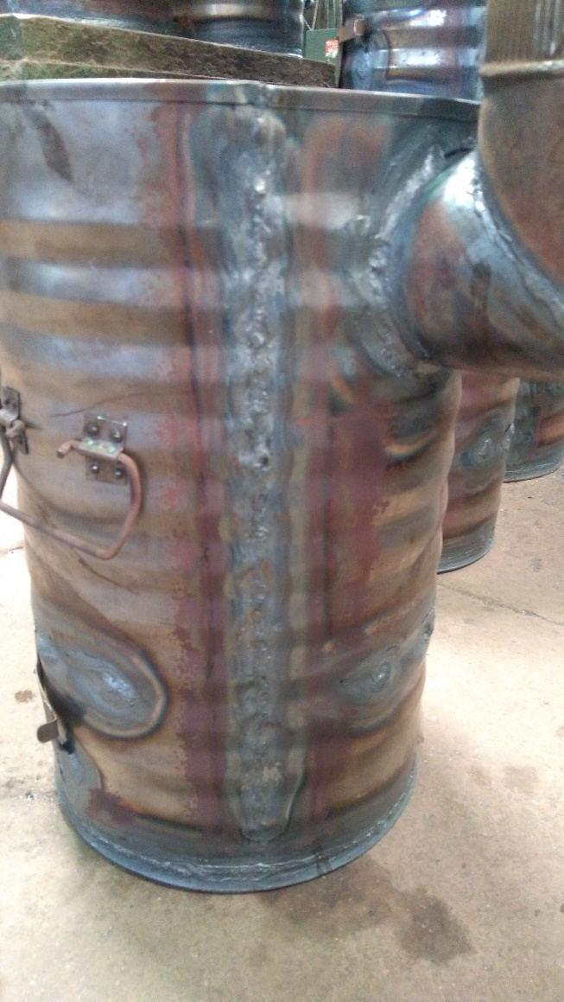

**Fig.6. Seam Welding**

* **SURFACE FINISH PROCESS:**
* **SURFACE FINISH** also known as surface texture or surface topography , is the nature of a nature of a surface as defined by three characteristics or lay , surface roughness & waviness .
* Each manufacturing process produces the surface.
* **PAINTING PROCESS:**

* **Painting** is the last process to do in the oil burner .
* After doing it , the product is dried for some days .
* Then proceed forward

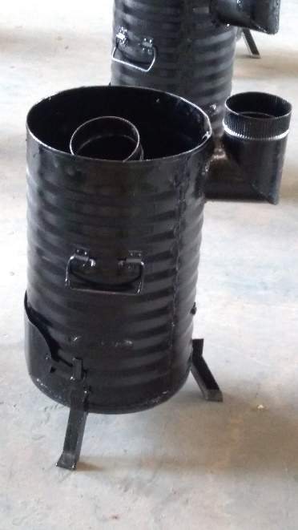

**Fig. 7. HSOB (product is in ready condition**

**THANK YOU**